Student’s name | …………………………………………………….…… | Grade | 4
Subject | Computer | Week No. | 5
Lesson Title | Animate with Scratch | Unit
Worksheet No. ( 5 )

Instruction: Color the parts of computer.


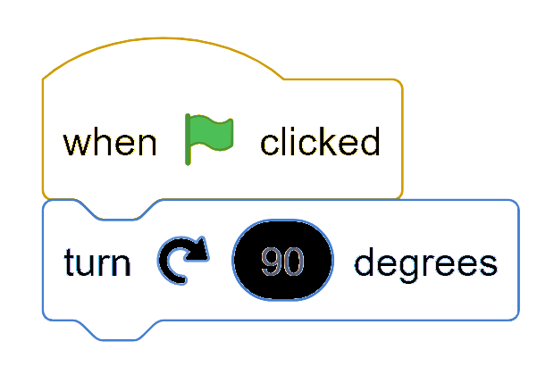
Good Luck

